# Installation of Inmeta.Exception.Service.Reader

When installed this service will poll the external Inmeta Exception Reporter Web Site for new exceptions and inject these into the local TFS.

The component marked in green frame in the diagram below is the one being installed.

This document relates to the installation of this component component

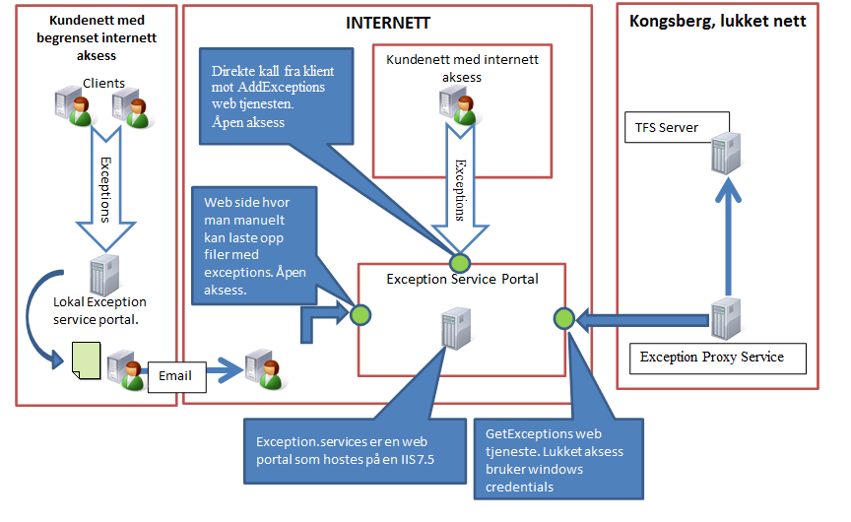

Installation steps:

1. Locate and start the file: “Inmeta.Exception.Service.Reader.Setup.msi”
2. Click Next in this dialog:

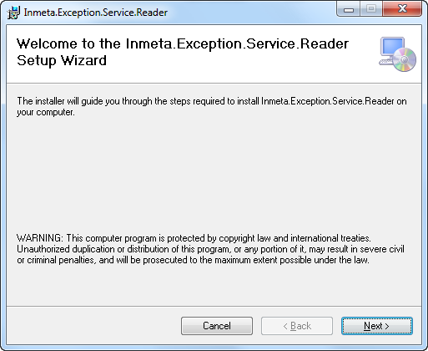

1. Click next in this dialog:

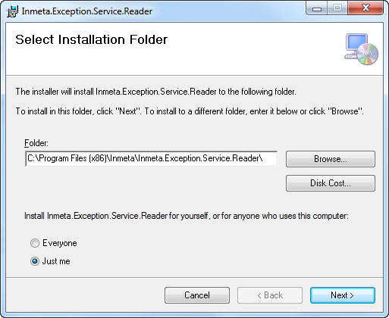

1. Click next in this dialog:

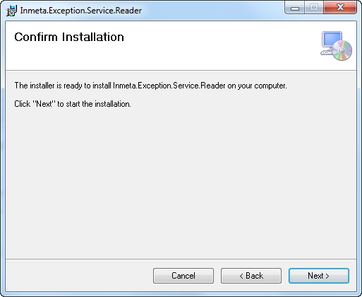

1. Add Information:
   1. Service URL is the location of the Exception Reporter web Site
   2. For anonymous access click next.
   3. For user based access on the ‘exception reporter web site’ enter credentials.
      1. Username
      2. Password
      3. Domain
2. Start service with name ‘ExceptionReaderService’.